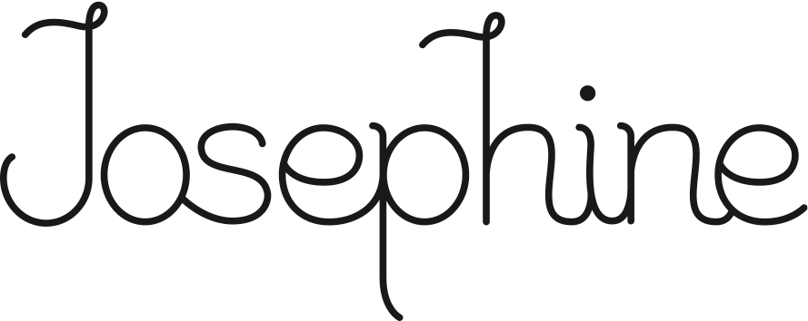

# — HAPPY HOUR —

5:00PM – 7:00PM Wed – Sun.

SOMMELIER’S CHOICE - $7

Cava – Chic Barcelona

Spain NV

Sauvignon Blanc - Crusher

California 2017

Petite Sirah – Ironstone

Lodi, California 2017

HAPPY HOUR SPECIAL **- $7**

Rye, Vanilla, Sweet Vermouth, Angostura

HAP & HARRY’S *NEON LEON*

LIGHT LAGER - $5

THE MUSIC CITY - $9

Hap & Harry’s *Neon Leon* Light Lager

&

Standard Proof Hickory Rye



# — HAPPY HOUR —

5:00PM – 7:00PM Wed – Sun.

DOUBLE CHEESEBURGER

7oz Josephine Reserve Ground Beef, Lettuce, Onion, Pickles, Special Sauce - $8

**- CHEESESTEAKS -**

BALBOA

Rib Eye, J Wiz, Onions – $12

PAULIE

Rib Eye, Onions, Mushrooms, Peppers,

Pizza Sauce, J Wiz - $12

MIGHTY MICK

Rib Eye, Onions, Lettuce, Duke’s,

American Cheese – $12

YO, ADRIAN

Two Burger Patties, American Cheese, Burger Sauce, Lettuce, Onion, Pickle,

Rib Eye, J Wiz - $15

CREED

Rib Eye, Onions, Cherry Pepper Relish,

Mushrooms, J Wiz - $12

**UTZ POTATO CHIPS** – $1.5

* NO MODIFICATIONS OR SUBSTITUTIONS PLEASE



# — HAPPY HOUR —

5:00PM – 7:00PM Wed – Sun.

DOUBLE CHEESEBURGER

Josephine Reserve Grind Beef, Lettuce, Onion, Pickles, Special Sauce - $7

**- CHEESESTEAKS -**

BALBOA

Rib Eye, J Wiz, Onions – $12

PAULIE

Rib Eye, Onions, Mushrooms, Peppers,

Pizza Sauce, J Wiz - $12

MIGHTY MICK

Rib Eye, Onions, Lettuce, Duke’s,

American Cheese – $12

YO, ADRIAN

Two Burger Patties, American Cheese, Burger Sauce, Lettuce, Onion, Pickle,

Rib Eye, J Wiz - $15

CREED

Rib Eye, Onions, Cherry Pepper Relish,

Mushrooms, J Wiz - $12

**UTZ POTATO CHIPS** – $1.5

* NO MODIFICATIONS OR SUBSTITUTIONS PLEASE



# — HAPPY HOUR —

5:00PM – 7:00PM Wed – Sun.

SOMMELIER’S CHOICE - $7

Cava – Chic Barcelona

Spain NV

Sauvignon Blanc - Crusher

California 2017

Petite Sirah – Ironstone

Lodi, California 2017

HAPPY HOUR SPECIAL **- $7**

Rye, Vanilla, Sweet Vermouth, Angostura

HAP & HARRY’S *NEON LEON*

LIGHT LAGER - $5

THE MUSIC CITY - $9

Hap & Harry’s *Neon Leon* Light Lager

&

Standard Proof Hickory Rye